**EXPERIMENT-1**

1. Create a vector c = [5,10,15,20,25,30] and write a program which returns the maximum and minimum of this vector.

Sol.

v1 = c(5,10,15,20,25,30)

print("The vector is: ")

print(v1)

print(paste("Maximum value of vector is: ",max(v1)))

print(paste("Minimum value of vector is: ",min(v1)))

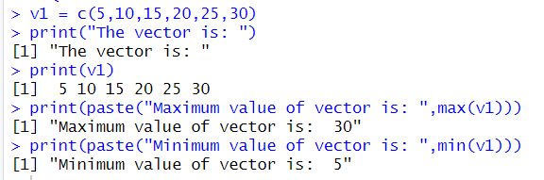

(2) Write a program in R to find factorial of a number by taking input from user. Please

print error message if the input number is negative.

Sol.

num = as.integer(readline(prompt="Enter the number: "))

factorial = 1

if(num < 0) {

print("Factorial doesn't exist for negative numbers.")

} else if(num == 0) {

print("Factorial of 0 is 1.")

} else {

for(i in 1:num){

factorial = factorial * i

}

print(paste("The factorial of",num, "is", factorial))

}

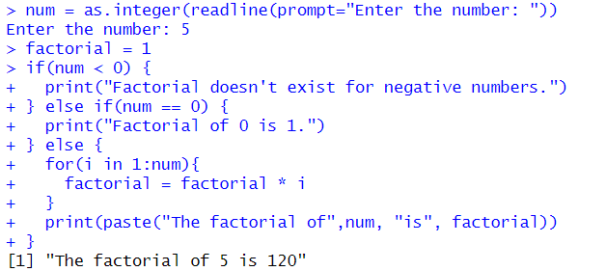

1. Write a program to write first n terms of a Fibonacci sequence. You may take n as an input from the user.

Sol.

fibonacci <- function(n) {

a <- 0

b <- 1

cat("Fibonacci Sequence:")

for (i in 1:n) {

cat(a, " ")

next_num <- a + b

a <- b

b <- next_num

}

}

number_of_terms = as.integer(readline(prompt="Enter the number: "))

fibonacci(number_of_terms)

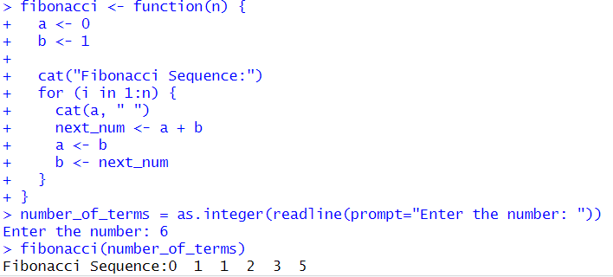

(4) Write an R program to make a simple calculator which can add, subtract, multiply

and divide.

Sol.

add <- function(x, y) {

return(x + y)

}

subtract <- function(x, y) {

return(x - y)

}

multiply <- function(x, y) {

return(x * y)

}

divide <- function(x, y) {

return(x / y)

}

print("Select operation.")

print("1.Add")

print("2.Subtract")

print("3.Multiply")

print("4.Divide")

choice = as.integer(readline(prompt="Enter choice[1/2/3/4]: "))

num1 = as.integer(readline(prompt="Enter first number: "))

num2 = as.integer(readline(prompt="Enter second number: "))

operator <- switch(choice,"+","-","*","/")

result <- switch(choice, add(num1, num2), subtract(num1, num2), multiply(num1, num2), divide(num1, num2))

print(paste(num1, operator, num2, "=", result))

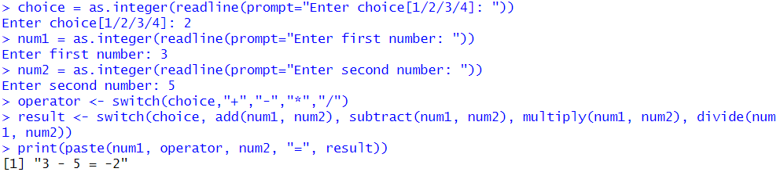

**(5) Explore plot, pie, barplot etc. (the plotting options) which are built-in functions in R.**

**Sol.**

x <- c(1, 2, 3, 4, 5)

y <- c(3, 5, 4, 6, 7)

plot(x, y, main = "Scatter Plot ", xlab = "X-axis", ylab = "Y-axis")

categories <- c("Category A", "Category B", "Category C")

values <- c(30, 45, 25)

pie(values, labels = categories, main = "Pie Chart Example")

categories <- c("Category A", "Category B", "Category C")

values <- c(30, 45, 25)

barplot(values, names.arg = categories, main = "Bar Plot Example", xlab = "Categories", ylab = "Values")

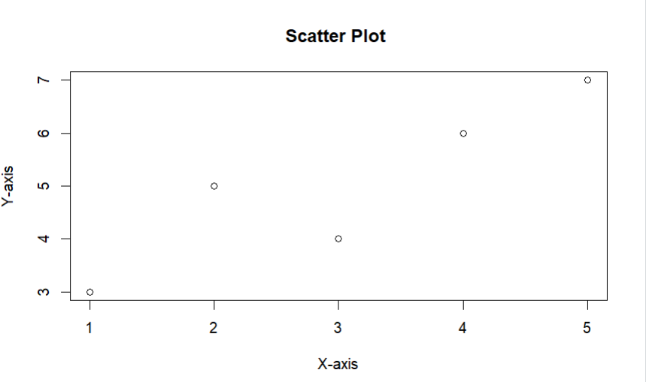

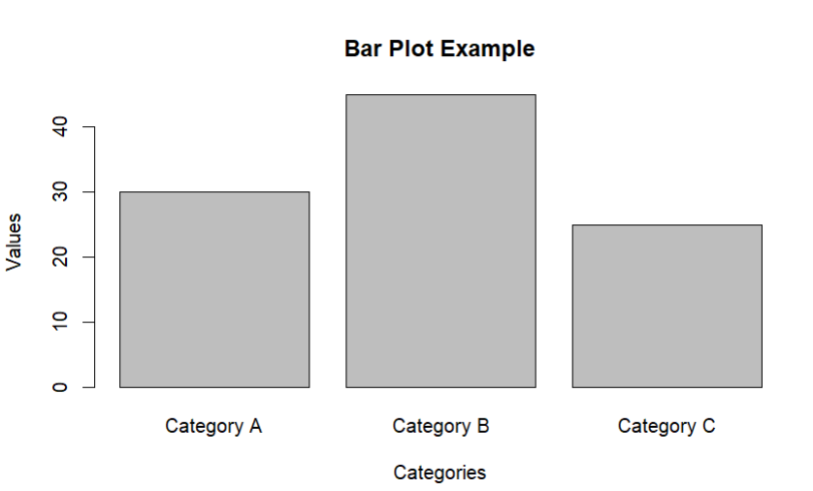

EXPERIMENT-2

(1) (a) Suppose there is a chest of coins with 20 gold, 30 silver and 50 bronze coins.

You randomly draw 10 coins from this chest. Write an R code which will give us the

sample space for this experiment. (use of sample(): an in-built function in R)

(b) In a surgical procedure, the chances of success and failure are 90% and 10%

respectively. Generate a sample space for the next 10 surgical procedures performed.

(use of prob(): an in-built function in R)

Sol.

choice<-c(rep('Gold',20),rep('Silver',30),rep('Bronze',50))

choice

ss<-sample(choice,10,replace=FALSE)

ss

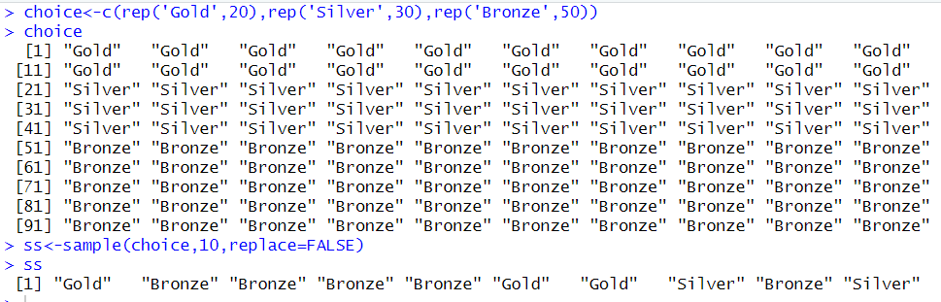

prob_success <- 0.9

prob_failure <- 0.1

sample_space <- sample(c("Success", "Failure"), 10, replace =TRUE, prob = c(prob_success, prob_failure))

sample_space

(2) A room has n people, and each has an equal chance of being born on any of the 365

days of the year. (For simplicity, we’ll ignore leap years). What is the probability

that two people in the room have the same birthday?

(a) Use an R simulation to estimate this for various n.

(b) Find the smallest value of n for which the probability of a match is greater than

.5.

Sol.

pbirthday(150, classes = 365, coincident = 2)

qbirthday(prob = 0.5, classes = 365, coincident = 2)

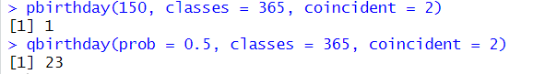

(3) Write an R function for computing conditional probability. Call this function to do

the following problem:

suppose the probability of the weather being cloudy is 40%. Also suppose the prob-

ability of rain on a given day is 20% and that the probability of clouds on a rainy day

is 85%. If it’s cloudy outside on a given day, what is the probability that it will rain

that day?

Sol.

conditional_probability <- function(prob_A, prob_B_given_A, prob_B) {

prob_A_given_B <- (prob_A * prob_B_given_A) / prob_B

return(prob_A_given_B)

}

prob_cloudy <- 0.4

prob_rain <- 0.2

prob_cloudy_given_rain <- 0.85

prob_rain_given_cloudy <- conditional_probability(prob_rain, prob_cloudy_given_rain, prob_cloudy)

cat("Probability of rain given it's cloudy:", prob_rain_given_cloudy, "\n")

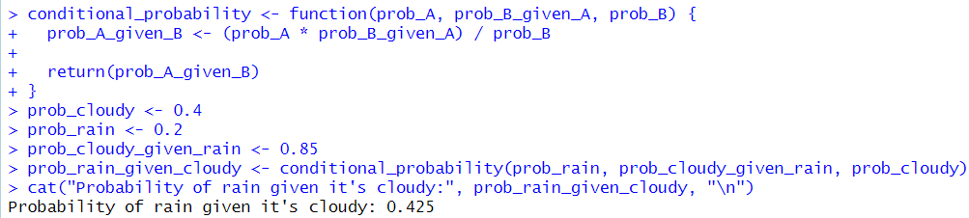

(4) The iris dataset is a built-in dataset in R that contains measurements on 4 different

attributes (in centimeters) for 150 flowers from 3 different species. Load this dataset

and do the following:

1. Print first few rows of this dataset.

df<-data.frame(iris)

head(df)

1. Find the structure of this dataset.

str(df)

1. Find the range of the data regarding the sepal length of flowers.

range(iris$Sepal.Length)



1. Find the mean of the sepal length.

mean(iris$Sepal.Length)



1. Find the median of the sepal length.

median(iris$Sepal.Length)



1. Find the first and the third quartiles and hence the interquartile range.

quantile(iris$Sepal.Length, c(0.25, 0.75))

IQR(iris$Sepal.Length)

1. Find the standard deviation and variance.

sd(iris$Sepal.Length)

var(iris$Sepal.Length)

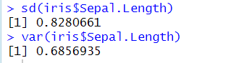

1. Try doing the above exercises for sepal.width, petal.length and petal.width.

# Find the range of sepal Width

range(iris$Sepal.Width)

# Find the mean of sepal Width

mean(iris$Sepal.Width)

# Find the median of sepal Width

median(iris$Sepal.Width)

# Find the quartiles and interquartile range of sepal Width

quantile(iris$Sepal.Width, c(0.25, 0.75))

IQR(iris$Sepal.Width)

# Find the standard deviation and variance of sepal Width

sd(iris$Sepal.Width)

var(iris$Sepal.Width)

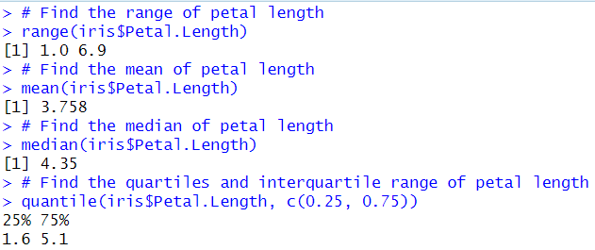

(i) Use the built-in function summary on the dataset Iris.

Sol.

summary(df)

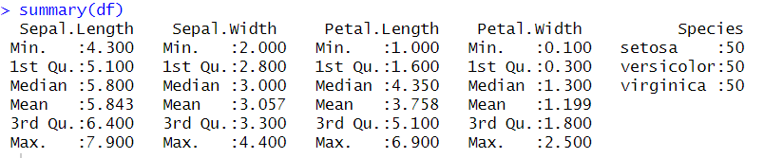

(5) R does not have a standard in-built function to calculate mode. So we create a user

function to calculate mode of a data set in R. This function takes the vector as input

and gives the mode value as output.

Sol.

data <- c(1,1,2,2,2,3,3,4,4,5,5,5,5)

cal_mode <- function(vec)

{

f_table<-table(vec)

max_freq<-max(f_table)

mode_value<-as.numeric(names(f_table[f_table==max_freq]))

return (mode_value)

}

cal_mode(data)

**EXPERIMENT-3**

(1) Roll 12 dice simultaneously, and let X denotes the number of 6’s that appear. Calcu-

late the probability of getting 7, 8 or 9, 6’s using R. (Try using the function pbinom;

If we set S = {get a 6 on one roll}, P(S) = 1/6 and the rolls constitute Bernoulli tri-

Also; thus X ∼ binom(size=12, prob=1/6) and we are looking for P(7 ≤ X ≤ 9).

Sol.

p <- pbinom(9, size = 12, prob = 1 / 6) - pbinom(6, size = 12, prob = 1 / 6)

p



(2) Assume that the test scores of a college entrance exam fits a normal distribution.

Furthermore, the mean test score is 72, and the standard deviation is 15.2. What is

the percentage of students scoring 84 or more in the exam?

Sol.

b <- pnorm(84, 72, 15.2, lower.tail = FALSE)

b

(3) On the average, five cars arrive at a particular car wash every hour. Let X count the

number of cars that arrive from 10AM to 11AM, then X ∼Poisson(λ = 5). What is

probability that no car arrives during this time. Next, suppose the car wash above

is in operation from 8AM to 6PM, and we let Y be the number of customers that

appear in this period. Since this period covers a total of 10 hours, we get that Y ∼

Poisson(λ = 5×10 = 50). What is the probability that there are between 48 and 50

customers, inclusive?

Sol.

x <- dpois(0, lambda = 5)

x

y <- ppois(50, lambda = 50) - ppois(47, lambda = 50)

y

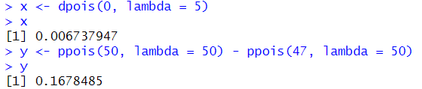

(4) Suppose in a certain shipment of 250 Pentium processors there are 17 defective pro-

cessors. A quality control consultant randomly collects 5 processors for inspection to

determine whether or not they are defective. Let X denote the number of defectives

in the sample. Find the probability of exactly 3 defectives in the sample, that is, find

P(X = 3).

Sol.

a <- dhyper(3, 17, 233, 5)

a

(5) A recent national study showed that approximately 44.7% of college students have

used Wikipedia as a source in at least one of their term papers. Let X equal the

number of students in a random sample of size n = 31 who have used Wikipedia as a

source.

1. How is X distributed?

X is Binomially Distributed

1. Sketch the probability mass function.

1. Sketch the cumulative distribution function.

1. Find mean, variance and standard deviation of X.

n <- 31

prob <- 0.447

mean <- n * prob

var <- n * prob * (1 - prob)

sd <- sqrt(var)

mean

var

sd

**EXPERIMENT-4**

1. The probability distribution of X, the number of imperfections per 10 meters of a

synthetic fabric in continuous rolls of uniform width, is given as

Find the average number of imperfections per 10 meters of this fabric.

(Try functions sum( ), weighted.mean( ), c(a %*% b) to find expected value/mean.

Sol.

x <- c(0:4)

p_x <- c(0.41, 0.37, 0.16, 0.05, 0.01)

sum(x * p_x)

weighted.mean(x, p_x)

c(x %*% p_x)

2. The time T, in days, required for the completion of a contracted project is a random

variable with probability density function f(t) = 0.1 e(-0.1t)

for t > 0 and 0 otherwise. Find the expected value of T.

Use function integrate( ) to find the expected value of continuous random variable T.

Sol.

func <- function(t) {

t * 0.1 * 2.71 ^ (-0.1 * t)

}

integrate(func, 0, Inf)$value

3. A bookstore purchases three copies of a book at $6.00 each and sells them for $12.00

each. Unsold copies are returned for $2.00 each. Let X = {number of copies sold} and

Y = {net revenue}. If the probability mass function of X is

Find the expected value of Y.

Sol.

x <- c(0:3)

p <- c(0.1, 0.2, 0.2, 0.5)

a <- sum(x*p)

b <- 10*a-12

b

4. Find the first and second moments about the origin of the random variable X with

probability density function 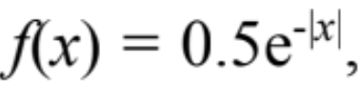 1 < x < 10 and 0 otherwise. Further use the

results to find Mean and Variance.

Mean = first moment and Variance = second moment – Mean^2

Sol.

func2 <- function(t) {

t * 0.5 * exp(-t)

}

mean_value <- integrate(func2, 1, 10)$value

mean_value

func3 <- function(t) {

t^2 * 0.5 * exp(-t)

}

sec_moment <- integrate(func3, 1, 10)$value

sec_moment

vari <- sec_moment - (mean_value^2)

vari

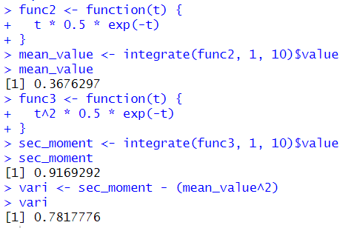

5. Let X be a geometric random variable with probability distribution

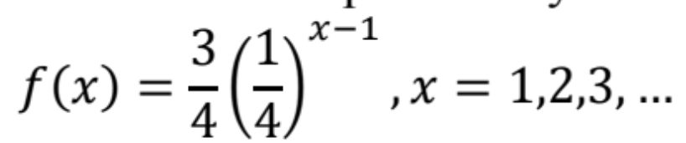

Write a function to find the probability distribution of the random variable Y = X^2

And find probability of Y for X = 3. Further, use it to find the expected value and variance of

Y for X = 1,2,3,4,5.

Sol.

f5 <- function(y) {

(3/4)*((1/4)^((y^(1/2))-1))

}

x <- 3

y <- x^2

f5(y)

x <- c(1:5)

y <- x^2

mean <- sum(y*f5(y))

mean

var <- sum(y*y*f5(y)) - mean*mean

var

